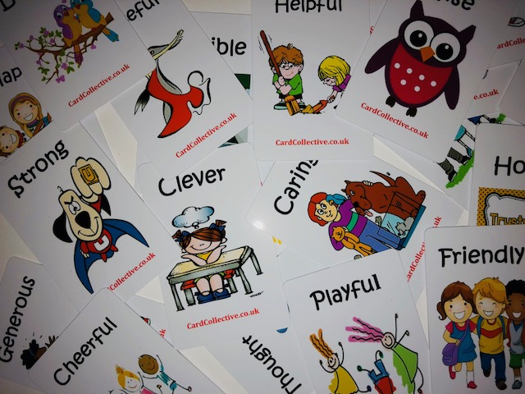

We use these Strength Cards in 1-1 sessions or group work, asking the child to select 4 cards which represent strengths they feel they have, we explore their choices with them, in group work we ask children to select a strength for a child and feedback to the child why they see that strength in them. We find that being PVC ( plastic vinyl coated) cards it makes them very tough and durable, easy to wipe over after being handled, children like the bright pictures and we find it helps them to explore their inner strengths and make them more aware.