The Emotional Literacy Support Assistant (ELSA) Project in Middlesbrough

2018-2020

Delivered by Middlesbrough Psychology Service
Dr Hannah Barker, Educational Psychologist
Dr Lisa Garforth, Specialist Senior Educational Psychologist
Dr Stephanie Hindmarch, Educational Psychologist
Helen Robertson, Doctoral Trainee Educational Psychologist
Natalia Hall, Doctoral Trainee Educational Psychologist

Evaluation of ELSA Training in Middlesbrough

Cycle 1 Evaluation

Qualitative data
Trainees were asked to evaluate each ELSA session. Thematic analysis of the qualitative data led to the following themes, which represent some of the immediate impact of the ELSA training, from the perspectives of trainees (please see pages 9-11).
Quantitative data
Trainees were also asked to provide an overall rating of each session ranging from 1 (very poor) to 10 (very good). 93% of rating provided by ELSAs were a 9 or 10 out of 10. No ratings below an 8 out of 10 were given.

“Loved the perspectives and questions to clarify – it is good to share!”

“I found hearing other practitioners experiences and resolutions most useful”

“I found group discussions most useful”

“Listening to TAs from other schools and the good practices they have in place”

“I found sharing knowledge, strategies and different perspective between settings most helpful”

“The group and leaders are supportive and approachable”

The power of group discussion

“I had children in mind who I support and….areas of emotional literacy I will look at more closely when working with them”
“Drawing to ideal self tool gives me a true insight of the child’s own perceptions, rather than the teacher’s”
“Mindfulness-brilliant. Will use personally and at school”
“I had never thought about writing a therapeutic story. I didn’t realise I could do it"
“Will help me personally interacting with staff in a more positive way when dealing with a problem”
“Loved resources- be able to delve deeper to get a lot more out of students”
“How to better understand the needs of students and maybe look more in-depth about why they have reacted in certain ways”
“Lego-based intervention was very interesting. I could see many children benefitting from this”
Skills and tools to support Emotional Literacy
“I will think differently about emotional regulation and how to support children with this”
“To focus a lot more on slowing down, especially with children who are struggling”
“Today has made me think differently about my attunement and whether I am as attuned as I thought”
“Remember to always think positive and find the time”
“I will take more time to observe and try to understand from the child’s perspective and be an active voice for them”
“Today has made me think differently about how I can adapt my own practices”
“Today’s session made me reflect on all the little things that I already do and all the benefits of these”
Time and space to reflect and develop thinking
“I will think differently about the impact of belongingness on a group and the simple measures that can be taken”

“Today, supported my knowledge of emotional literacy and its importance of supporting the pupils I work with”

“I am more aware of the range and scale of autistic differences”

“I have a better understanding of different conditions (ASC), how they present and how to support ch/yp ”

“A deeper understanding of emotional literacy and what this looks like in ourselves and our students”

Theme: Deeper knowledge and understanding of psychological concepts

“X has absolutely loved the training and it has made us re-structure our whole provision in the New Year”

“All areas were fascinating. Everything was a complete package showing me how much you can gain from weekly sessions with children”
Additional feedback

“Love this course and know the students will too- very excited”

Cycle 2 Evaluation

Qualitative data
Trainees were asked to complete an evaluation after each training session. Thematic analysis of their responses led to the creation of themes. These themes represent the perspectives of ELSAs and may demonstrate some of the immediate impact of the ELSA training.
The tables represents the themes generated from the perspectives of the ELSAs in response to the following questions:
1) What have ELSAs found useful in each of the ELSA training sessions?
2) What have ELSAs taken away from their training?
Quantitative Data
Trainees were asked to provide an overall rating of each session ranging from 1 (very poor) to 10 (very good). 94% of rating provided by ELSAs were a 9 or 10 out of 10. No ratings below an 8 out of 10 were given.

Thematic analysis of ELSA - Cycle 2
ELSAs were asked to complete an evaluation after each training session. Thematic analysis of their responses led to the creation of themes. These themes represent the perspectives of ELSAs and may demonstrate some of the immediate impact of the ELSA training.
The table below represents the themes generated from the perspectives of the ELSAs about what they found useful in each of the ELSA training sessions:

What have ELSAs found useful in their training sessions?

What have ELSAs taken away from their training?
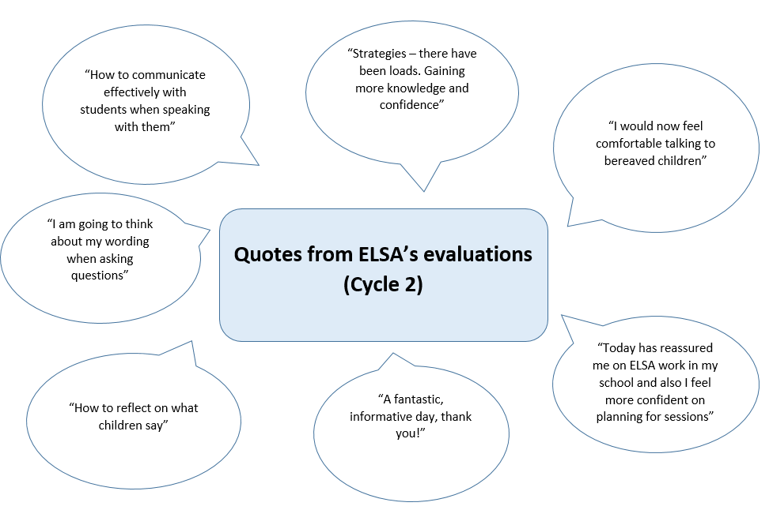
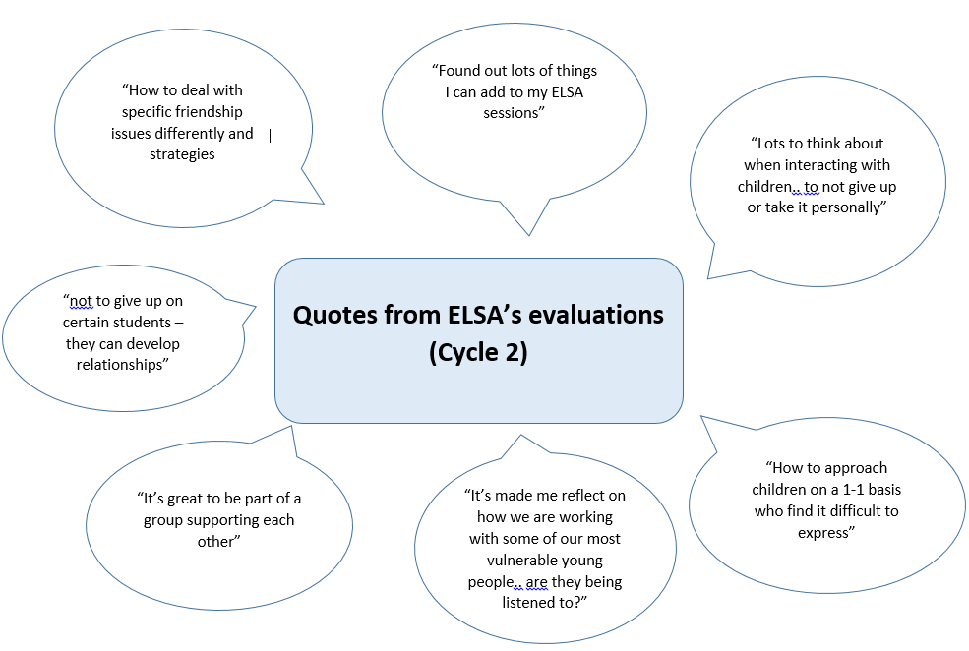

Next steps for Evaluation
Proposed next steps for Middlesbrough Psychology Service will be to evaluate:
- At the beginning of their ELSA training, teaching assistants completed a self-efficacy questionnaire. At a suitable point in the future we will ask them to complete this questionnaire again to explore any changes which may be a result of ELSA training and supervision.
- The impact of ELSA intervention on outcomes for pupils.
- The impact of ELSA within a whole school context (e.g. school practice, for parents).

