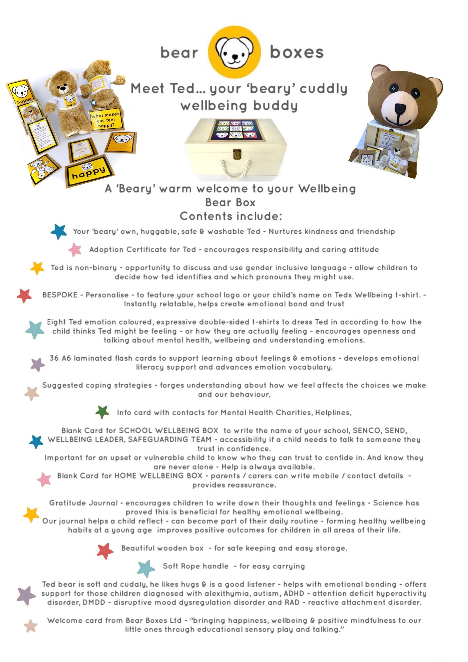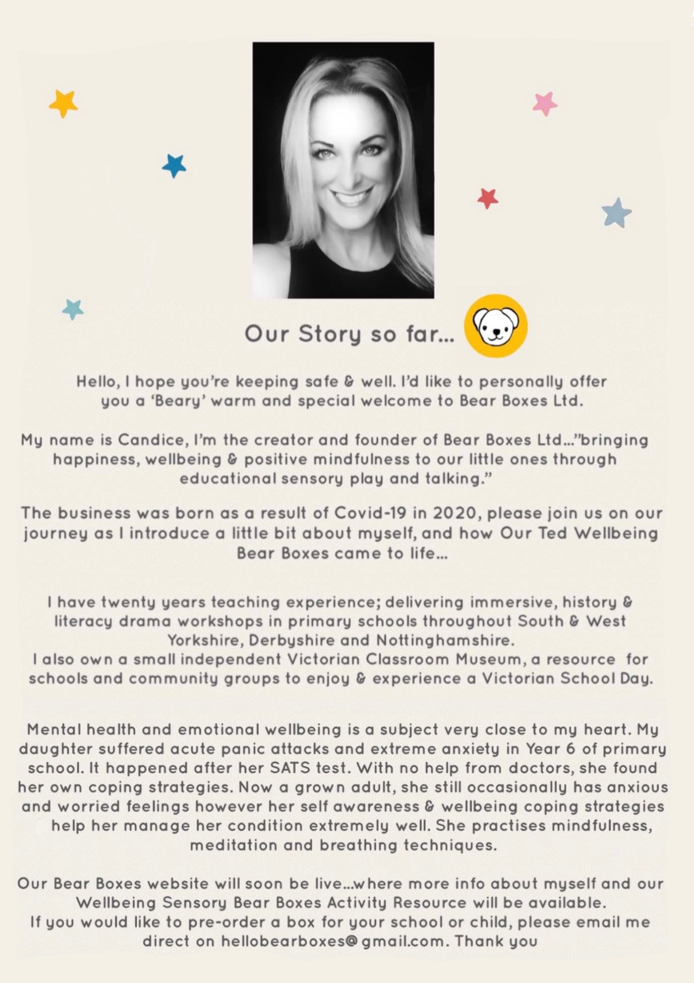
Purchases can be made by direct email to hellobearboxes@gmail.com . An invoice with bank transfer details will be sent when order is placed. There is currently a special introductory price of £39.99 per single box + P&P. Usual price for a single Wellbeing Bear Box is £59.99 + P&P (£4.95).

